# 

# **Department of Computer Science and Engineering Islamic University of Technology (IUT)** A subsidiary organ of OIC

# **Laboratory Report**

# CSE 4412: Data Communication and Networking Lab

## 

## **Name:** Chowdhury Ashfaq **Student ID:** 200042123 **Section:** A **Semester:** 4th **Academic Year:** 2021-22

**Date of Submission:**

### **Title:** Configuration of OSPF in a network topology.

### **Objective**:

1. Understand Link State Routing Protocol
2. Understand OSPF
3. Understand the difference between DV and LS routing

### **Devices/ software Used**:

1. 4 Router-PT
2. 4 2960-24TT switches
3. 1 PC
4. 1 Server-PT

### **Theory:**

**Link State (LS) Routing**

The protocol that determines the best path to transport data packets between networks is Link State Routing.It mainly takes bandwidth and some other metrics like current state to determine the path.

**Link-State Database (LSDB)**

Using the LSDB each node in a network creates a database for itself which has the complete view of a network. It is used to determine the best path.

**Link State Packet**

LS Routing uses LSP which is basically a data structure used to advertise information about the state of network resources. This is used to build a calculate the shortest path to other routers in the network. When there’s a change in state then LSP is updated. Routers determine recent LSP using the sequence number.

**Open Shortest Path First (OSPF)**

**Metric:** Bandwidth of a link.

**Areas:** OSPF employs a hierarchical framework where routers in a specific area preserve a comprehensive understanding of the network's structure using LSAs transmitted by other routers in the same area.

**Link State Advertisement (LSA):**

Link State advertisement (LSA) describes the state of the links and shares it with all other node in the network. It is used in Link State Routing.

**OSPF Implementation:**

1. OSPF periodically sends LSA to its neighbors to keep the states updated.
2. Using LSDB router finds the best path to send packets.

### **Performance:**

**Update Message:** In a network using OSPF, when something changes, the routers quickly tell their nearby routers what happened, and these updates spread through the network. One special router, called the DR, helps by sending these updates to all the other routers on its part of the network. The other routers will only listen to the DR and another special router called the BDR. If some other router tries to send an update, it won't be heard.

**Convergence of Forwarding Tables:** When something changes in a network, like a link breaking or a new part being added, all the routers need to adjust their "maps" of the network (called routing tables) to reflect this. Routing table convergence means the time it takes for all the routers to finish updating their maps so they match the new network layout.

### **Diagram of the experiment:**

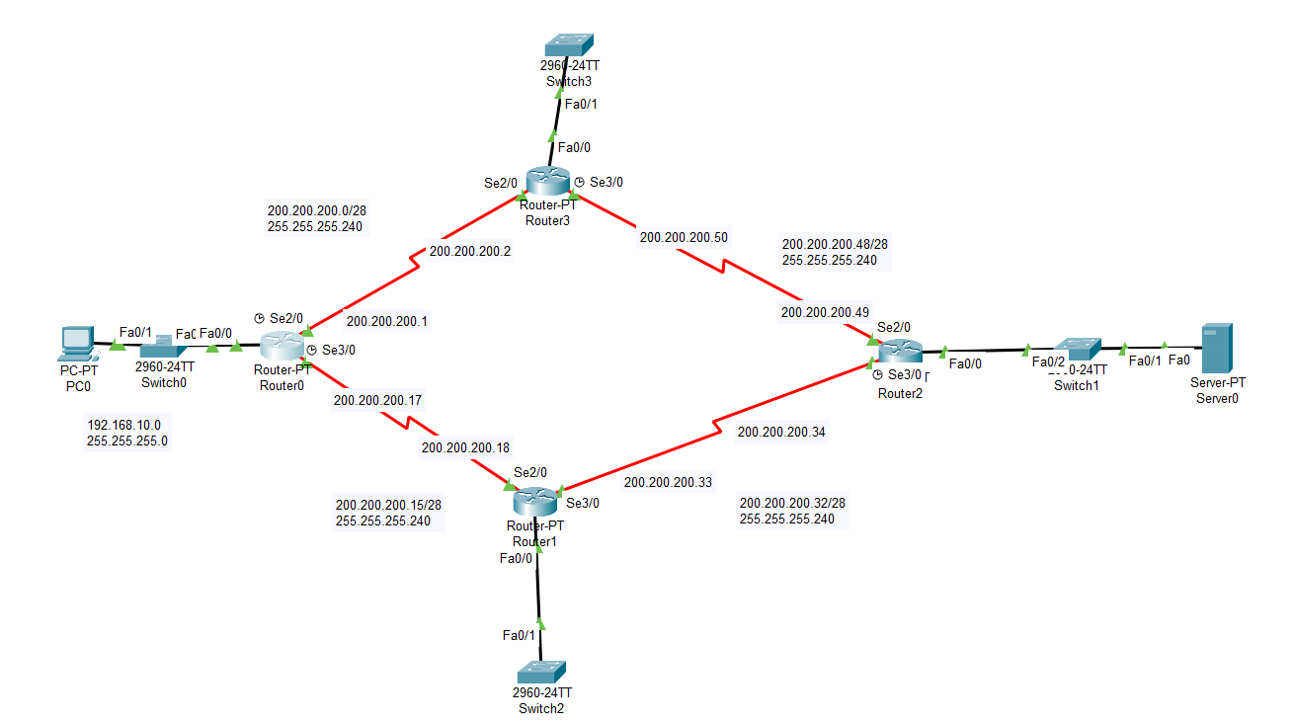

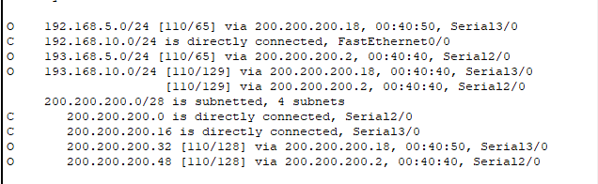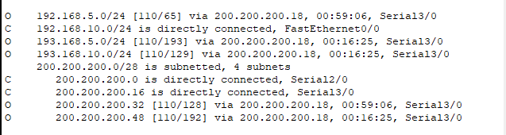

**Fig**: Routing table before and after changing bandwidth of Se2/0 to 1

### **Configuration of Routers:**

Commands for configuring OSPF

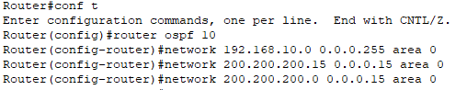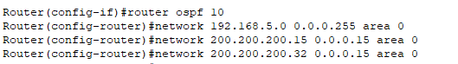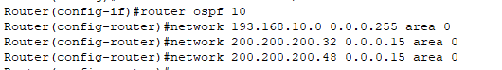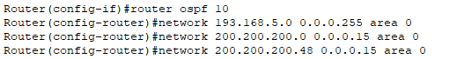

### **Observation**:

The screenshots of routing table of each router is shown below:

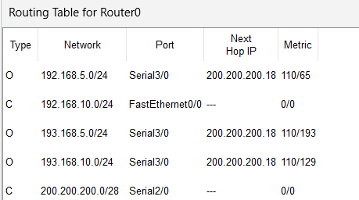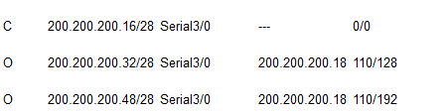

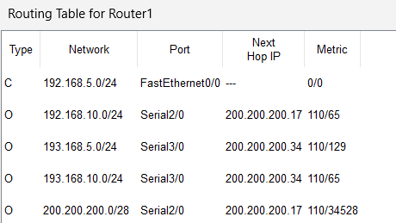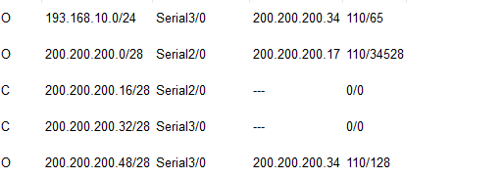

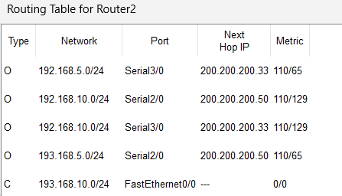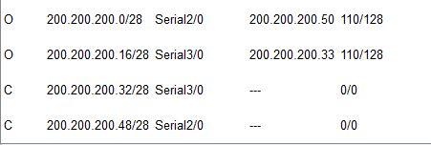

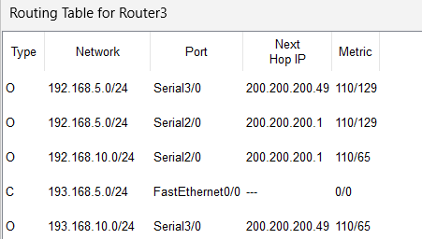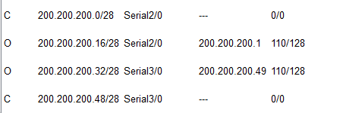

### **Challenges:**

* Visualizing the use of OSPF. The routing table in most cases is updated a certain interval so we need to fast forward after which we can visualize the change due to OSPF.